Please, prepare your contribution using this template. Remove all red text before submitting in .doc format. Please, do not insert page numbers. You may adapt wording of headings as needed but you need to maintain the format style of the templates (fonts of headings and body, margins, referencing style).
Final length: Research paper and Practice paper: 6-8 p (excl references). Workshop 4-6 pages (see workshop instructions).

(4 spaces)
TITLE OF THE PAPER
Since we are using double-blind reviewing process, do not add your name, position, affiliation, etc. until to the final camera ready paper. However, leave room for them.
(2 spaces)
Initials Last name
Affiliation
Town, Country
ORCID
(1 space)
Initials Last name
Affiliation
Town, Country
ORCID
(2 spaces)
Conference Key Areas: Please select two Conference Key Areas
Keywords: Please select one to five keywords
ABSTRACT
Maximum 250 words. Lorem ipsum dolor sit amet, consectetur adipiscing elit, sed do eiusmod tempor incididunt ut labore et dolore magna aliqua. Ut enim ad minim veniam, quis nostrud exercitation ullamco laboris nisi ut aliquip ex ea commodo consequat. Duis aute irure dolor in reprehenderit in voluptate velit esse cillum dolore eu fugiat nulla pariatur. Excepteur sint occaecat cupidatat non proident, sunt in culpa qui officia deserunt mollit anim id est laborum.

Introduction (Arial,12 pt, bold, Capital letters)

Section 1 (Arial 12 pt, bold)
Lorem ipsum dolor sit amet, consectetur adipiscing elit, sed do eiusmod tempor incididunt ut labore et dolore magna aliqua. Ut enim ad minim veniam, quis nostrud exercitation ullamco laboris nisi ut aliquip ex ea commodo consequat.
Duis aute irure dolor in reprehenderit in voluptate velit esse cillum dolore eu fugiat nulla pariatur. Excepteur sint occaecat cupidatat non proident, sunt in culpa qui officia deserunt mollit anim id est laborum. (Arial 12 pt)

Section 2
Lorem ipsum dolor sit amet, consectetur adipiscing elit, sed do eiusmod tempor incididunt ut labore et dolore magna aliqua. Ut enim ad minim veniam, quis nostrud exercitation ullamco laboris nisi ut aliquip ex ea commodo consequat. Duis aute irure dolor in reprehenderit in voluptate velit esse cillum dolore eu fugiat nulla pariatur. Excepteur sint occaecat cupidatat non proident, sunt in culpa qui officia deserunt mollit anim id est laborum.

Methodology

Section 1
Lorem ipsum dolor sit amet, consectetur adipiscing elit, sed do eiusmod tempor incididunt ut labore et dolore magna aliqua. Ut enim ad minim veniam, quis nostrud exercitation ullamco laboris nisi ut aliquip ex ea commodo consequat. Duis aute irure dolor in reprehenderit in voluptate velit esse cillum dolore eu fugiat nulla pariatur. Excepteur sint occaecat cupidatat non proident, sunt in culpa qui officia deserunt mollit anim id est laborum.

Section 2
Lorem ipsum dolor sit amet, consectetur adipiscing elit, sed do eiusmod tempor incididunt ut labore et dolore magna aliqua. Ut enim ad minim veniam, quis nostrud exercitation ullamco laboris nisi ut aliquip ex ea commodo consequat. Duis aute irure dolor in reprehenderit in voluptate velit esse cillum dolore eu fugiat nulla pariatur. Excepteur sint occaecat cupidatat non proident, sunt in culpa qui officia deserunt mollit anim id est laborum.
Use the equation editor of Word with the standard settings (12 pt italic Arial). Equations shall be numbered. An example is given in Eq. (1).
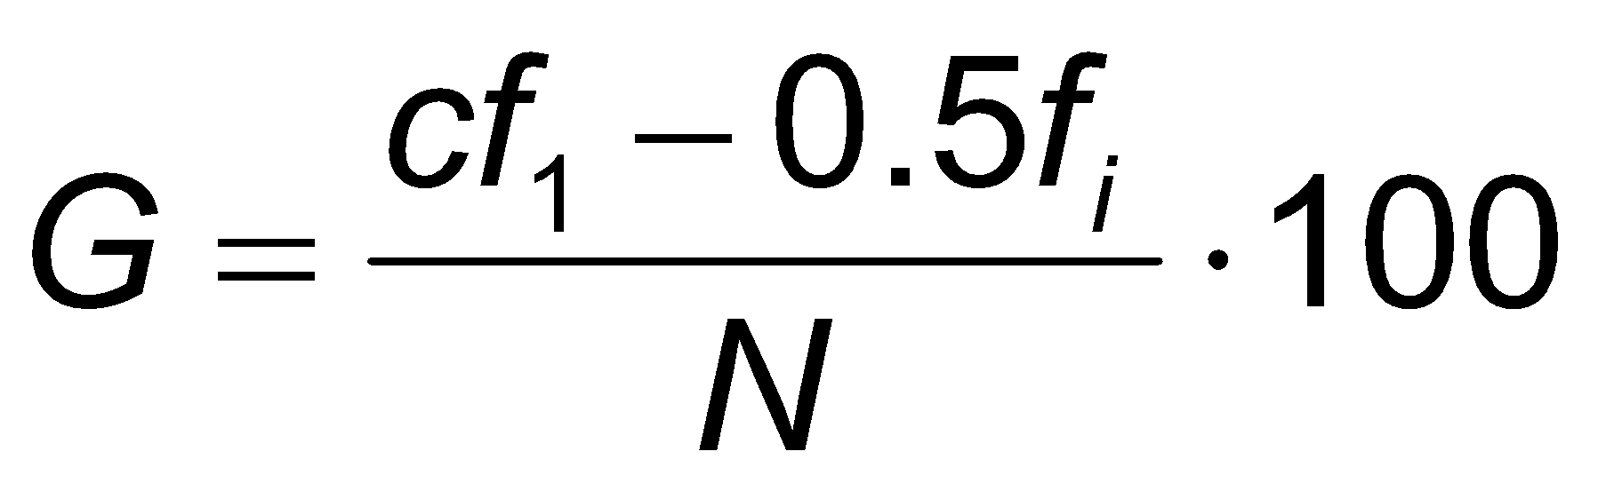 (1).

Results

Tables
Lorem ipsum dolor sit amet, consectetur adipiscing elit, sed do eiusmod tempor incididunt ut labore et dolore magna aliqua. Ut enim ad minim veniam, quis nostrud exercitation ullamco laboris nisi ut aliquip ex ea commodo consequat. Duis aute irure dolor in reprehenderit in voluptate velit esse cillum dolore eu fugiat nulla pariatur. Excepteur sint occaecat cupidatat non proident, sunt in culpa qui officia deserunt mollit anim id est laborum.
Table 1. Margins of the page size A4 [mm]
Top | bottom | Inside | outside
20 | 20 | 25 | 25

Figures
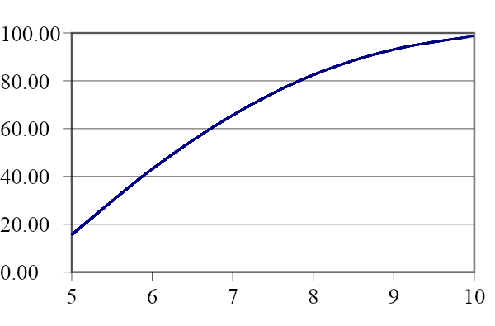 | 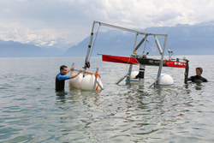
Fig. 1. Drawing | Fig. 2. Student MAKE project Hydrocontest

Summary and acknowledgements
Summary and acknowledgments are optional.

REFERENCES
The reference style used should follow Chicago Style with intext citation in the style Author-Date. For citation in the text of your submitted paper please use short citations in round brackets. Use only the surname of the author followed by the year of publication: eg (Author 2023), (AuthorA and AuthorB 2023) or if citing more than 3 authors use (Author et al. 2023).
Reference examples are provided below. For other examples and further information please follow to: https://www.chicagomanualofstyle.org/
Please order your references alphabetically.

Since we are using double-blind reviewing process, also references revealing the identity of the author(s) should be made anonymous until the final camera ready paper.

Examples of Reference Styles

Journal Article with DOI
Article Author, A. A., and B. B. Article Author. "Title of Article." Title of Journal volume number, no. issue number (Month or Season Year): inclusive page or paragraph numbers. https://doi.org/10.XXX/XXXXX.XX.
Journal Article in Print Journal
Article Author, A. A., and B. B. Article Author. "Title of Article." Title of Journal volume number, no. issue number (Month or Season Year): inclusive page numbers.
Conference Paper with DOI
Author of Paper, A., and B. Author of Paper. "Title of Paper." Paper presented at Title of Conference: Subtitle of Conference, Location, Date. https://doi.org/10.XXX/XXXXX.XX
Conference Paper in Print
Author of Paper, A., and B. Author of Paper. "Title of Paper." In Title of Published Proceedings: Subtitle of Conference, Location, Date, inclusive page numbers. Place of publication: Publisher.
Published Theses
Author, A. A. Title of Thesis: Subtitle. Place of publication: Publisher, Year.

Books
Author, A. A., and B. B. Author. Title: Subtitle. Edition. Place of publication: Name of Publisher, Year.

Corresponding Author (All in Arial, 10 pt, single space) Intials Last name e-mail address Since we are using double-blind reviewing process, do not add your name, position, affiliation, etc. until to the final camera ready paper

